Table of Contents

Arm Geometry 2

Mesh Independence 3

Mesh 4

Static Structural Analysis and Results - 5

Applying 2N of load at the end of the arm at 3 different positions 5

Equivalent Maximum Stress on the arm at 0 degrees when applying various loads 10

Properties of Material 10

Design and ANSYS Static Structural Analysis of UR3e inspired Robotic Arm

# Arm Geometry

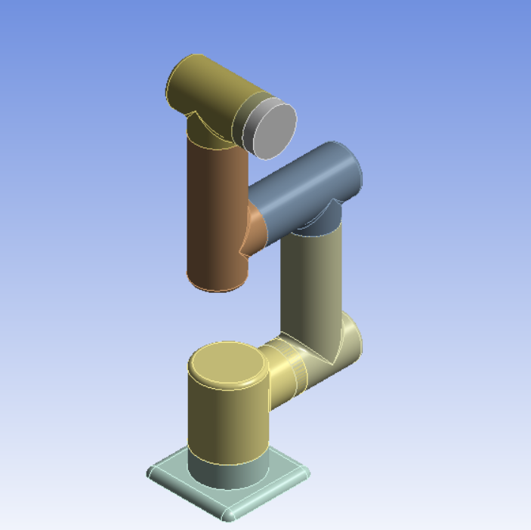

6 axis robotic arm design without end effector

# Mesh Independence

| Force X Component | Mesh Element Size | Equivalent Stress Maximum | P5 - Mesh Elements |
| --- | --- | --- | --- |
| N | mm | MPa |  |
| 20 | 10 | 5.21113 | 11196 |
| 20 | 5 | 3.373263 | 40608 |
| 20 | 4 | 2.714911 | 76898 |
| 20 | 3 | 4.157615 | 147718 |
| 20 | 2 | 3.771302 | 335064 |

# 

# 

# 

# 

# 

# 

# 

# 

# 

# 

# 

# 

# 

# 

# 

# Mesh

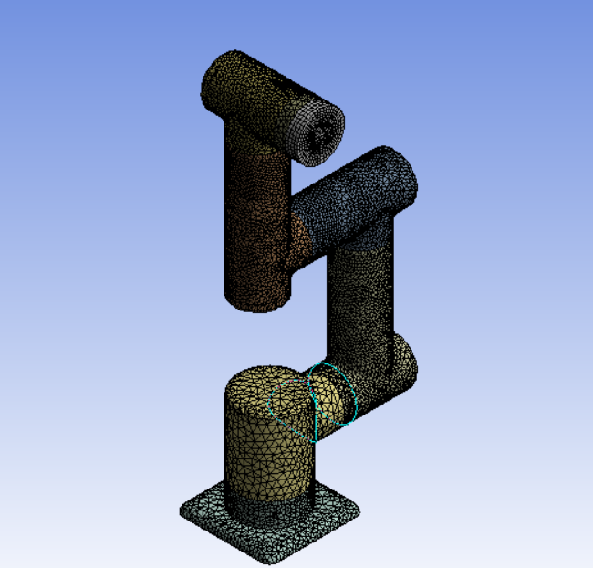

Mesh of the robotic arm

| **Bounding Box** | |
| --- | --- |
| Length X | 507.6 mm |
| Length Y | 489.84 mm |
| Length Z | 120. mm |
| **Properties** | |
| Volume | 1.1631e+006 mm³ |
| Mass | 1.4596 kg |
| Scale Factor Value | 1. |
| **Statistics** | |
| Nodes | 10822 |
| Elements | 4550 |
| Active Bodies | 13 |
| Bodies | 42 |
| Element Size | 4mm |

# Static Structural Analysis and Results -

# Applying 2N of load at the end of the arm at 3 different positions

**At 90 degrees with respect to the ground:**

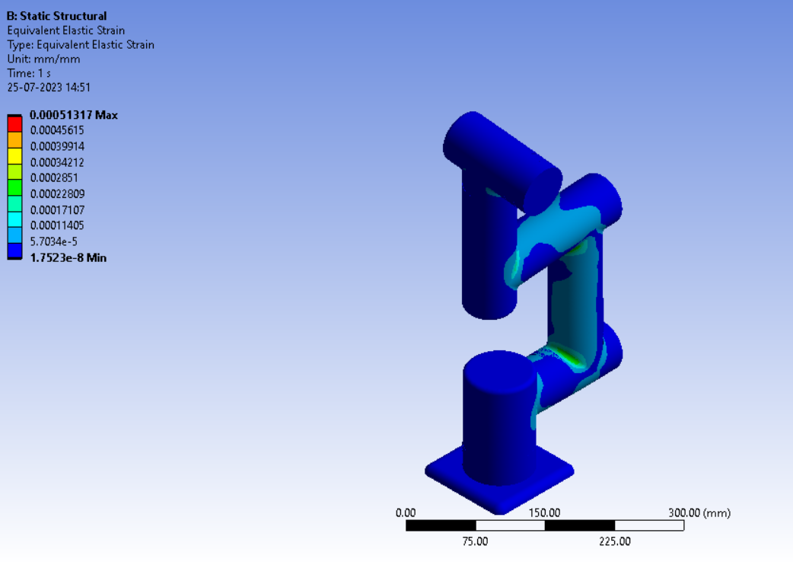

Equivalent Elastic Strain on the arm at 90 degrees

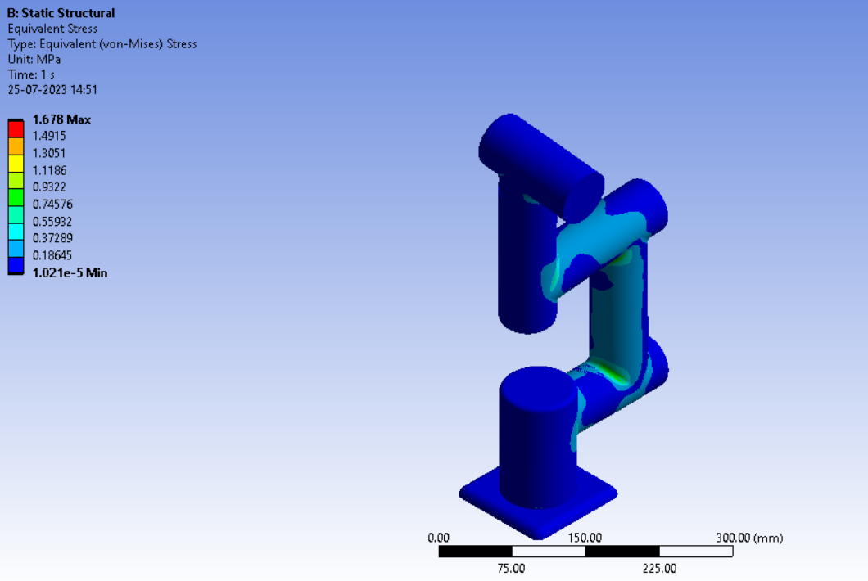

Equivalent Stress on the arm at 90 degrees

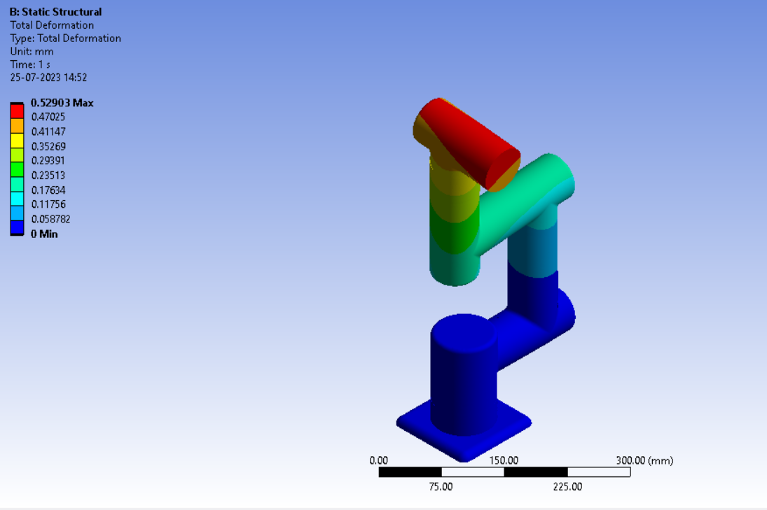

Total Deformation on the arm at 90 degrees

**At 60 degrees with respect to the ground:**

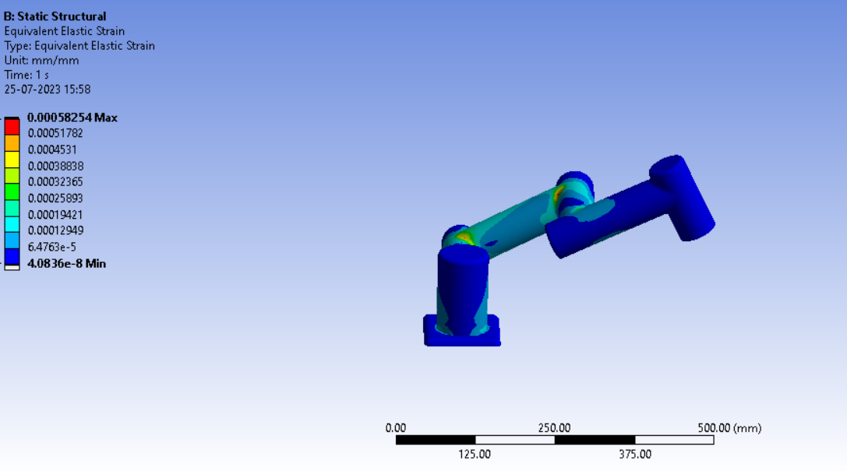

Equivalent Elastic Strain on the arm at 60 degrees

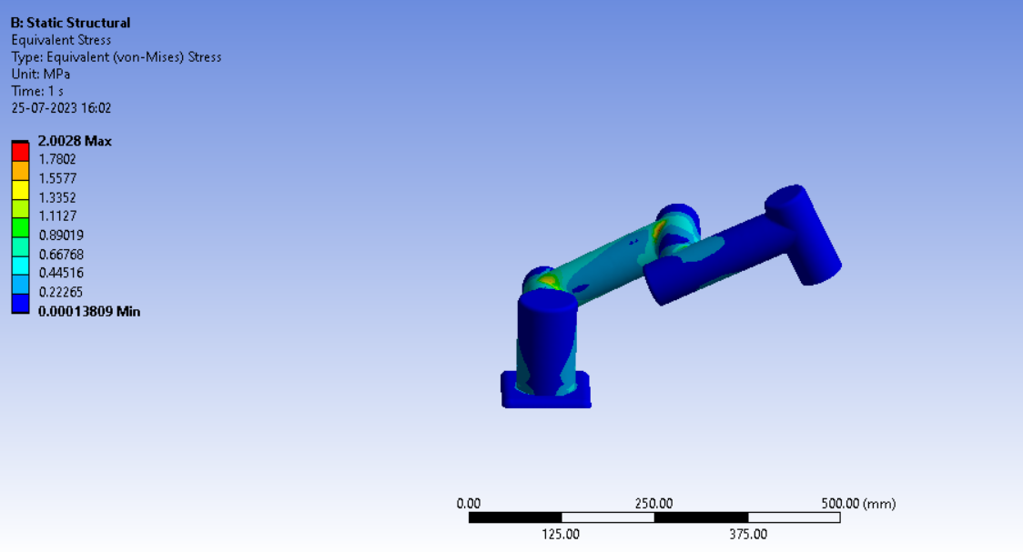

Equivalent Stress on the arm at 60 degrees

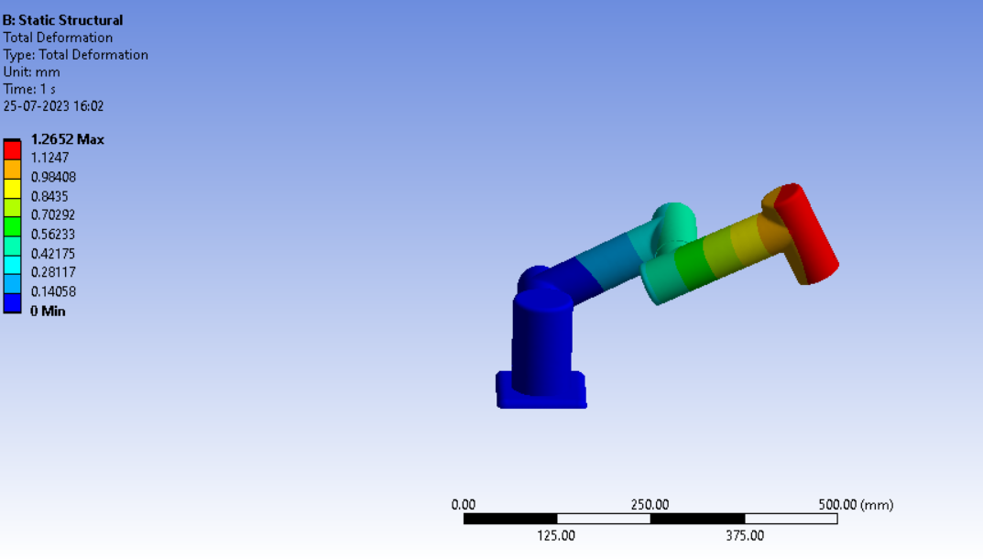

Total on the arm at 60 degrees

**At 0 degrees with respect to the ground:**

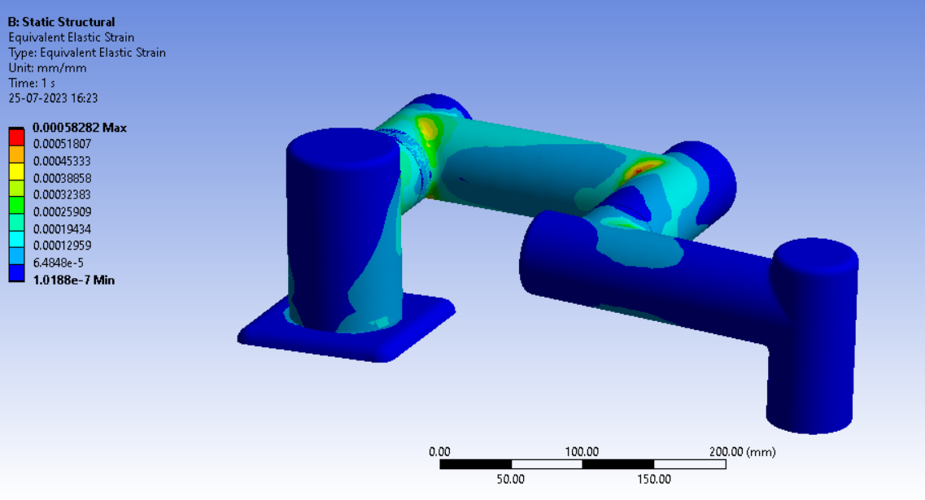

Equivalent Elastic Strain on the arm at 0 degrees

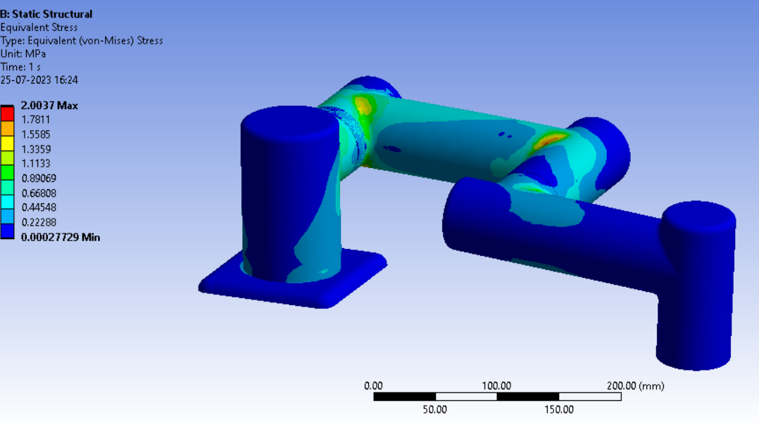

Equivalent Stress on the arm at 0 degrees

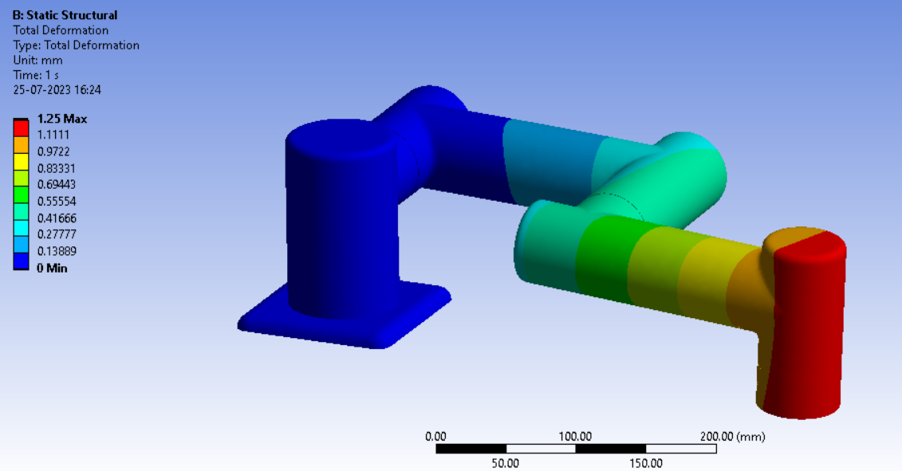

Total on the arm at 0 degrees

# Equivalent Maximum Stress on the arm at 0 degrees when applying various loads

| Name | Force X Component | Equivalent Stress Maximum | Mesh Elements |
| --- | --- | --- | --- |
| Units | N | MPa |  |
| 1. | 20 | 2.003697 | 36203 |
| 2. | 15 | 1.502773 | 36203 |
| 3. | 10 | 1.001848 | 36203 |
| 4. | 5 | 0.500924 | 36203 |
| 5. | 3 | 0.300555 | 36203 |
| 6. | 30 | 3.005545 | 36203 |

# Properties of Material

**PLA - Constants**

| Density | 1.255e-006 kg mm^-3 |
| --- | --- |
| Tensile Yield Strength | 52.44 MPa |
| Tensile Ultimate Strength | 62.93 MPa |
| Coefficient of Thermal Expansion | 1.352e-004 C^-1 |
| Thermal Conductivity | 1.442e-004 W mm^-1 C^-1 |
| Specific Heat | 1.195e+006 mJ kg^-1 C^-1 |
| Resistivity | 4.313e+012 ohm mm |

**PLA - Isotropic Elasticity**

| Young's Modulus MPa | Poisson's Ratio | Bulk Modulus MPa | Shear Modulus MPa | Temperature C |
| --- | --- | --- | --- | --- |
| 3447 | 0.3899 | 5218 | 1240 | 23 |